

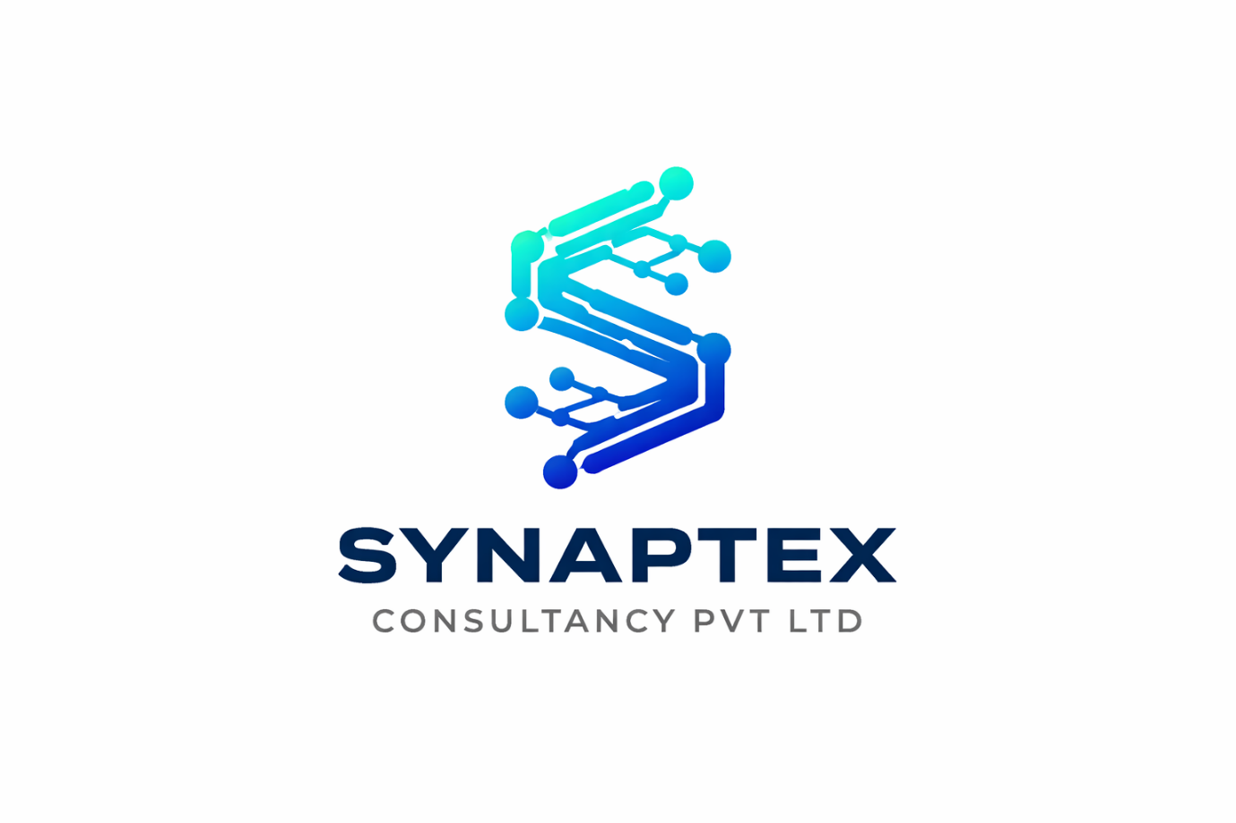
Empowering Business Through Smart Solutions

1.0 Company Profile
Synaptex Consultancy Pvt Ltd. is a forward-thinking and dynamic consultancy firm, established in 2023, committed to driving business growth, innovation, and operational excellence located in Sadiqabad, Rawalpindi, and regional office in Skardu Gilgit Baltistan. The company bridges the gap between traditional business practices and modern digital transformation.
Synaptex offers a comprehensive portfolio of services, including advanced IT solutions, procurement management, human resource development, digital marketing, travel and visa consultancy (Umrah, Ziarat, and ticketing), as well as advertising and printing solutions. The firm also specializes in delivering professional training programs, capacity-building workshops, and strategic market research to support informed decision-making.
At Synaptex, we combine industry expertise with innovative approaches to empower organizations, enhance efficiency, and deliver sustainable, long-term success in an increasingly competitive and evolving global environment.
2.0 Mission Statement:

To empower organizations with innovative IT solutions, practical training, and efficient procurement services that enhance operational efficiency, build capacity, and enable sustainable growth. We are committed to delivering excellence through collaboration, innovation, and integrity in every project we undertake.
3.0 Vision Statement:

To be a leading consultancy firm recognized for transforming businesses through cutting-edge technology, knowledge empowerment, and strategic excellence enabling clients to thrive in the digital age.
4.1 Travel and Tourism
Synaptex Consultancy Pvt Ltd. provides expert travel and tour consultancy for both domestic and international travelers. While we cater to a diverse range of adventurers and trekkers exploring the rugged landscapes of Pakistan, our core expertise lies in Religious Tourism. We specialize in curated travel experiences that combine spiritual significance with seamless logistics.
Key Partners & Clients:
- Karvan Noor Zehra: Specialized religious tour management.
- Rupal Expeditions: Adventure and trekking logistics.

4.2 Ticketing & Visa Consultancy
We provide comprehensive visa assistance and ticketing solutions tailored to the specific needs of the Gilgit-Baltistan community. Our services are strategically focused on peak travel windows (December–January and July–August) to ensure travellers have reliable support during high-demand seasons.
- Visa Consultancy: Expert guidance for Umrah (Makkah & Madina) and Ziarat (Iran, Iraq, and Syria) permits, ensuring all regulatory requirements are met for a worry-free pilgrimage.
- Ticketing Services: We offer competitive booking options for domestic and international carriers, including:
- Domestic: Pakistan International Airlines (PIA) and Air Blue.
- International/Pilgrimage: Dedicated booking via Iran Air, Iraqi Airways, and other regional carriers for Umrah and Ziarat routes. 
4.3 IT Solutions
Synaptex Consultancy Pvt Ltd. offers end-to-end information technology services designed to help organizations embrace digital transformation and improve operational efficiency. Our IT solutions include software development, system integration, IT infrastructure setup, cloud computing, cybersecurity, and digital automation. We provide tailored technology strategies aligned with each client’s unique business goals ensuring innovation, scalability, and seamless performance.
4.4 Professional Training
We design and deliver professional training programs that equip individuals and teams with the knowledge, skills, and tools needed to excel in their respective industries. Our training modules cover IT skills development, project management, leadership, communication, digital literacy, and emerging technologies.
Through our expert trainers and industry-driven content, we ensure that participants gain practical insights and applicable skills that contribute to both personal and organizational growth.
4.5 Workshops
Synaptex Consultancy Pvt Ltd. conducts interactive workshops focused on professional development, innovation, and technology adoption. These workshops are tailored to client needs, promoting hands-on learning, problem-solving, and strategic thinking.
Our workshop themes include digital transformation strategies, business process improvement, team collaboration, and innovation management helping organizations build high-performing teams ready for the challenges of the modern business environment.
4.5 Market Research
We provide comprehensive market research and analytical insights to help clients make informed business decisions. Our research services cover market analysis, competitive intelligence, consumer insights, feasibility studies, and policy research.
Using both qualitative and quantitative approaches, Synaptex Consultancy Pvt Ltd.. assists businesses in understanding market trends, identifying opportunities, and minimizing risks enabling data-driven strategies and sustainable growth.
4.6 Procurement Management
Synaptex Consultancy Pvt Ltd. provides strategic procurement and supply chain management services designed to streamline sourcing and optimize operational efficiency. We serve a diverse client including Travel & Tour operators (Umrah & Ziarat), Government Agencies, and Private Sector enterprises to ensure their procurement processes are transparent, cost-effective, and fully compliant with regulatory standards.
Our comprehensive procurement solutions include:
- Strategic Sourcing & Planning: Developing robust frameworks to identify and acquire essential resources.
- Tender & Bid Management: Managing the end-to-end bidding process to ensure fair competition and quality selection.
- Contract Negotiation: Securing favourable terms and ensuring legal and financial safeguards are in place.
- Vendor Performance Evaluation: Auditing and managing supplier relationships to maintain high service standards and supply chain resilience.
4.7 Digital Marketing
Synaptex Consultancy Pvt Ltd. empowers businesses to establish a dominant online presence. We specialize in tailoring digital growth strategies that resonate with both local audiences in Gilgit-Baltistan and international markets. Our approach combines data-driven insights with creative storytelling to build brand loyalty and drive conversions.
Our digital marketing suite includes:
- Social Media Management (SMM): Building and engaging communities across platforms like Facebook, Instagram, and LinkedIn to amplify your brand voice.
- Search Engine Optimization (SEO): Enhancing your visibility on search engines to ensure your business is the first choice for potential clients.
- Content Marketing & ADS Solutions: Crafting compelling visual and written content, supported by targeted advertising campaigns that maximize Return on Investment (ROI).
- Performance Analytics: Providing transparent reporting and data analysis to continuously refine strategies and ensure sustainable digital growth.


Our Team

Ghulam Hasnain
Chief Executive Officer & Managing Director
Email: arguni.hasnain@gmail.com
Phone No: 0345-2502478
LinkedIn: arguni_hasnain
Ghulam Hasnain serves as the Chief Executive Officer & Managing Director of Synaptex Consultancy Pvt Ltd.., bringing over 8 years of diverse professional experience across visa consultancy for B2B Conference for business communities, ticketing solutions for domestic travellers and tour operator and adventurers, industry research, market research, product research, IT consultancy, and policy advocacy for public and private sector organization. His career spans both the public sector and the private sector, giving him a unique, well-rounded perspective on Pakistan’s evolving regulatory, economic, and business landscape.
He has contributed to evidence-based policymaking, regulatory reforms, and advisory projects with national-level impact, including engagements with government bodies, private corporations, and development initiatives. His expertise is rooted in conducting in-depth sectoral assessments, formulating strategic insights, and delivering practical, data-driven solutions for businesses and institutions.
Ghulam Hasnain holds an MPhil degree from Quaid-i-Azam University, Islamabad, one of Pakistan’s premier academic institutions. His academic background, combined with years of hands-on experience, positions him to lead Synaptex Consultancy Pvt Ltd. with a vision centred on innovation, integrated service delivery, and measurable value creation.
Under his leadership, Synaptex Consultancy Pvt Ltd. continues to expand its footprint in IT solutions, procurement consulting, digital marketing, research services, training, and corporate support, offering clients a reliable one-stop platform for comprehensive consultancy and operational excellence.

Muhammad Sadiq
Director
Muhammad Sadiq is a visionary leader and a founding Director of Synaptex Consultancy Pvt Ltd. With a deep-rooted commitment to the socio-economic development of Gilgit-Baltistan, he oversees the strategic direction and long-term growth of the firm. His expertise lies in navigating complex operational landscapes and fostering institutional partnerships. Under his leadership, Synaptex has established itself as a trusted name in high-stakes consultancy, ensuring that every project—from procurement management to religious tourism—is executed with the highest standards of integrity and excellence.
Muhammad Baqir
Digital Marketing Expert
Director at Synaptex Consultancy Pvt Ltd., Muhammad Baqir brings an innovative and results-driven approach to the firm’s diverse service portfolio. He plays a pivotal role in spearheading the company’s digital transformation and capacity-building initiatives. With a focus on operational efficiency and modern technology integration, he ensures that Synaptex’s IT solutions, digital marketing strategies, and professional training programs stay ahead of market trends. His hands-on leadership is instrumental in delivering customized, high-impact solutions that empower clients to thrive in a competitive digital economy.
Our Offices

Rawalpindi
Address: Rajazar Road, Sadiqabad, Haji Chowk, Rawalpindi
Email: Synaptexconsultancypvtltd@gmail.com
WhatsApp: +92-3452502478
Website: www.synaptexconsultancy.pk
Facebook: @Synaptexconsultancypvtltd
Instagram: @Synaptexconsultancypvtltd

Regional Office
Skardu:
Address: Agha Hadi Chowk, Skardu
Email: Synaptexconsultancypvtltd@gmail.com
WhatsApp: +92-3452502478
Website: www.Synaptexconsultancy.pk
Facebook: @Synaptexconsultancypvtltd
Instagram: @Synaptexconsultancypvtltd

OUR PORTFOLIOS
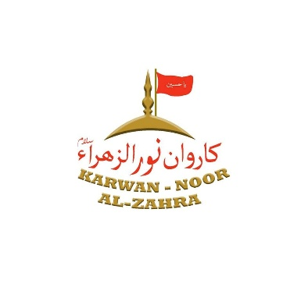
OUR SUBSIDARIES
- ARGUNI DRY FRUITS
Arguni Dry Fruits is a premium organic brand based in Skardu, Gilgit-Baltistan, dedicated to bringing the pure, nutrient-rich treasures of the Himalayas to the global market. We specialize in the sourcing, processing, and distribution of 100% natural dry fruits, nuts, and herbal products. Our mission is to promote a healthy lifestyle while supporting the local farming communities of Gilgit-Baltistan through ethical and sustainable trade practices.

